Name: Pranali Sonawane
Subject: MCSA
Date: 23-12-2025
Lab 17: Web Server and Shadow Copy

Server 1:
Add roles and Features next next Select Web Server (IIS) next Select Default Web Server Features install
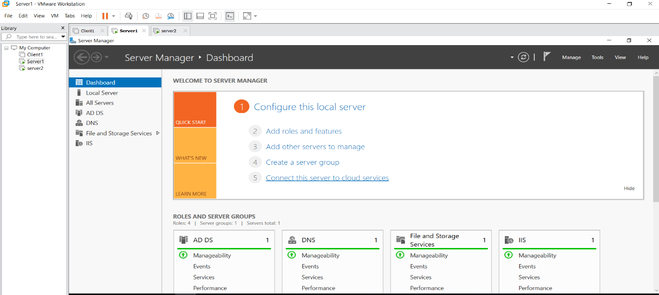
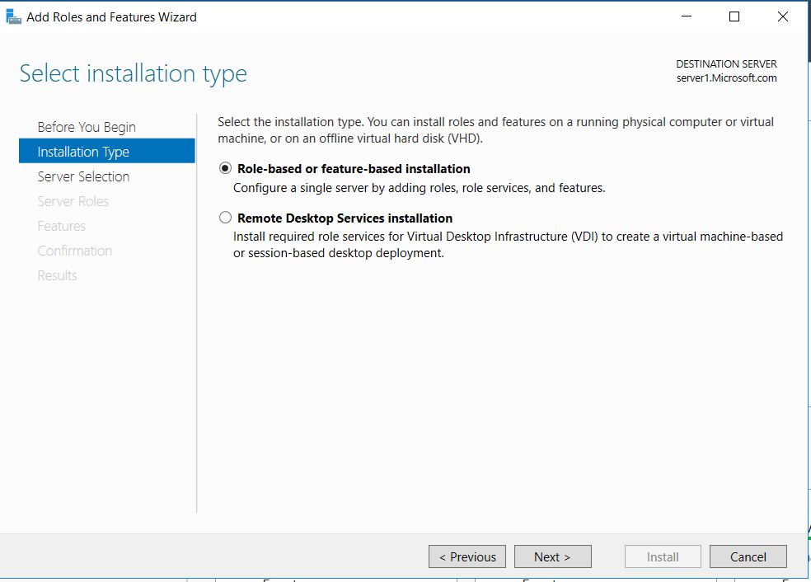
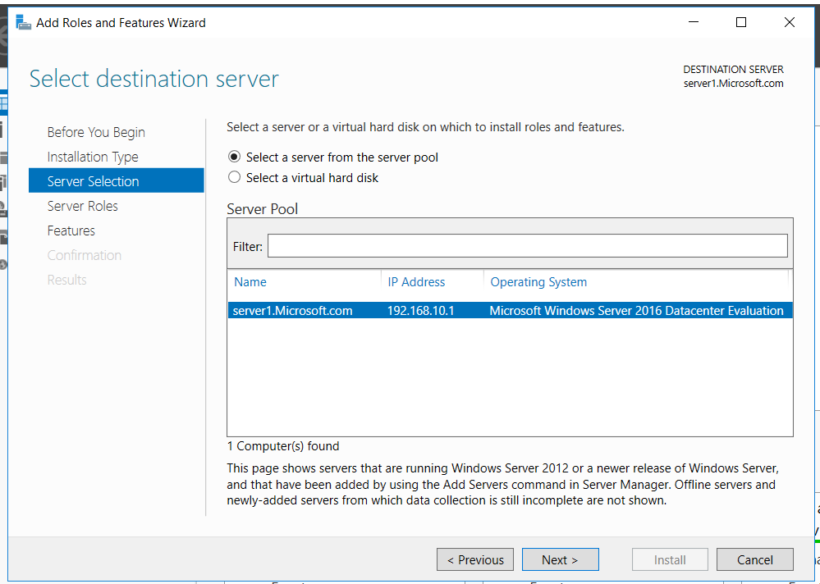
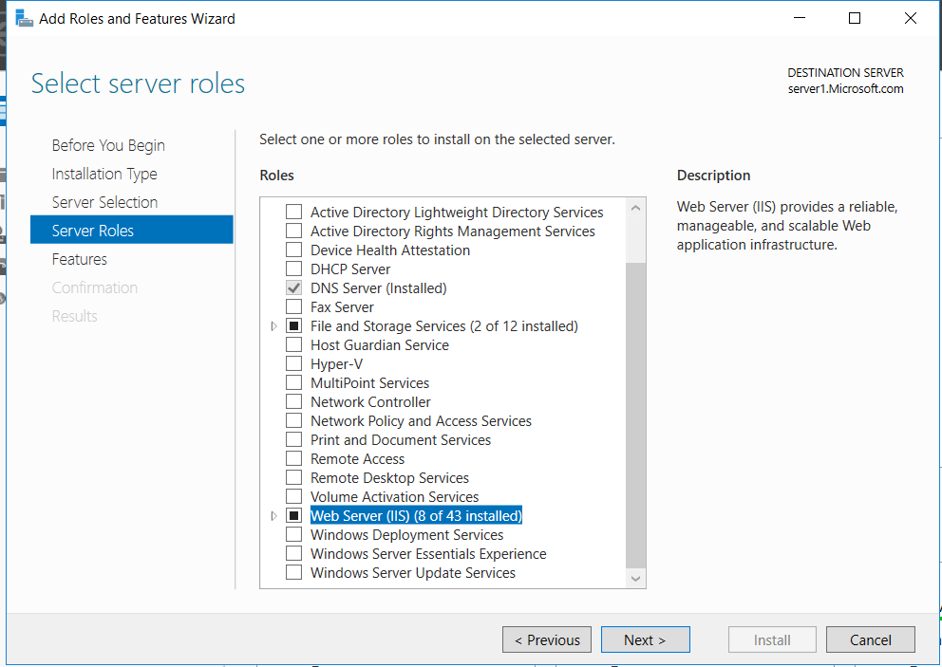
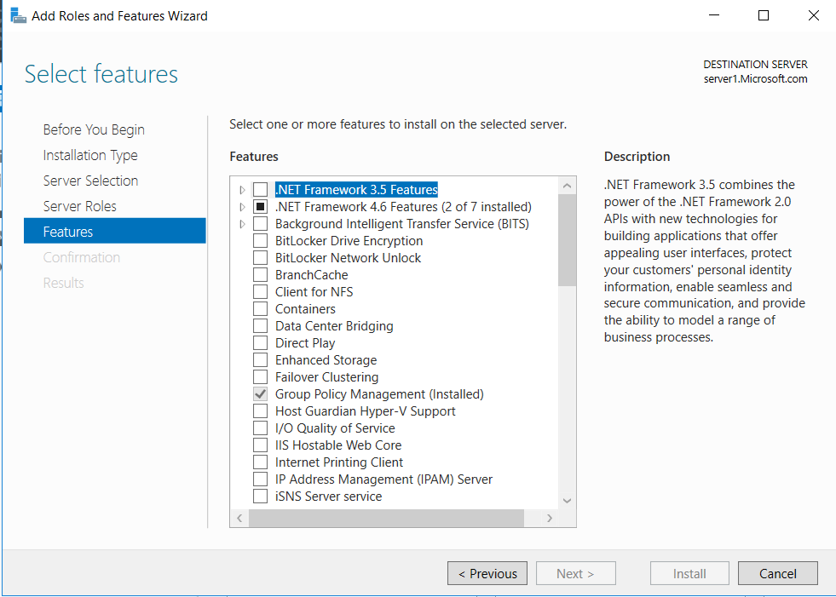
After that Select Default Web Server (IIS) Features install.

This PC Drive C inetpub wwwroot iisstart.htm right click open notepad write html code on your website also Open in Internet Explore Display Website.
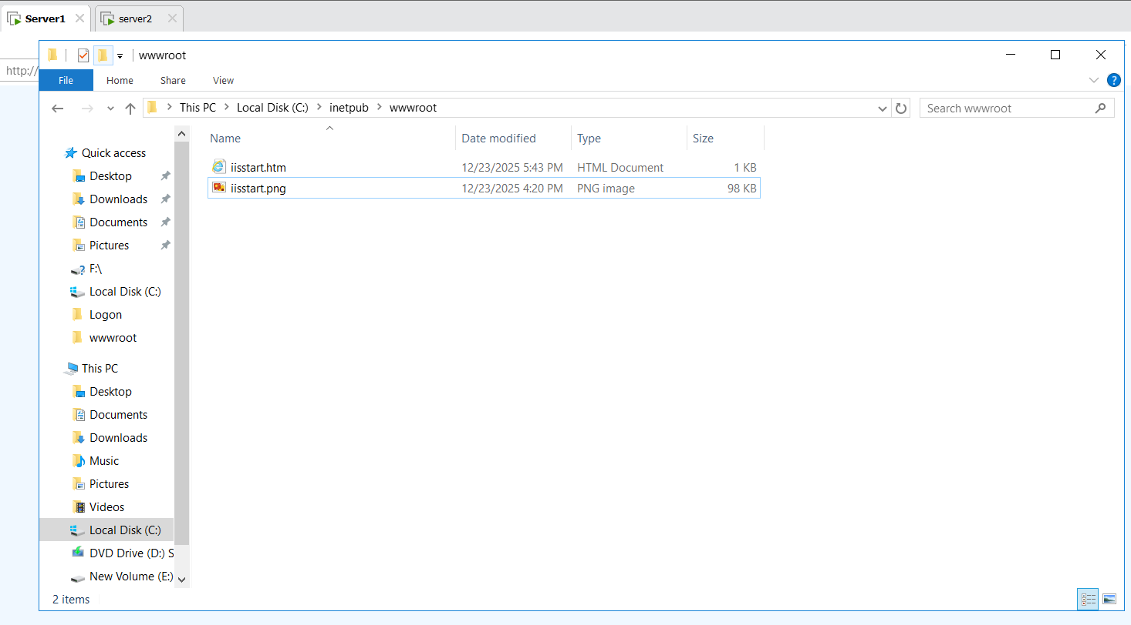
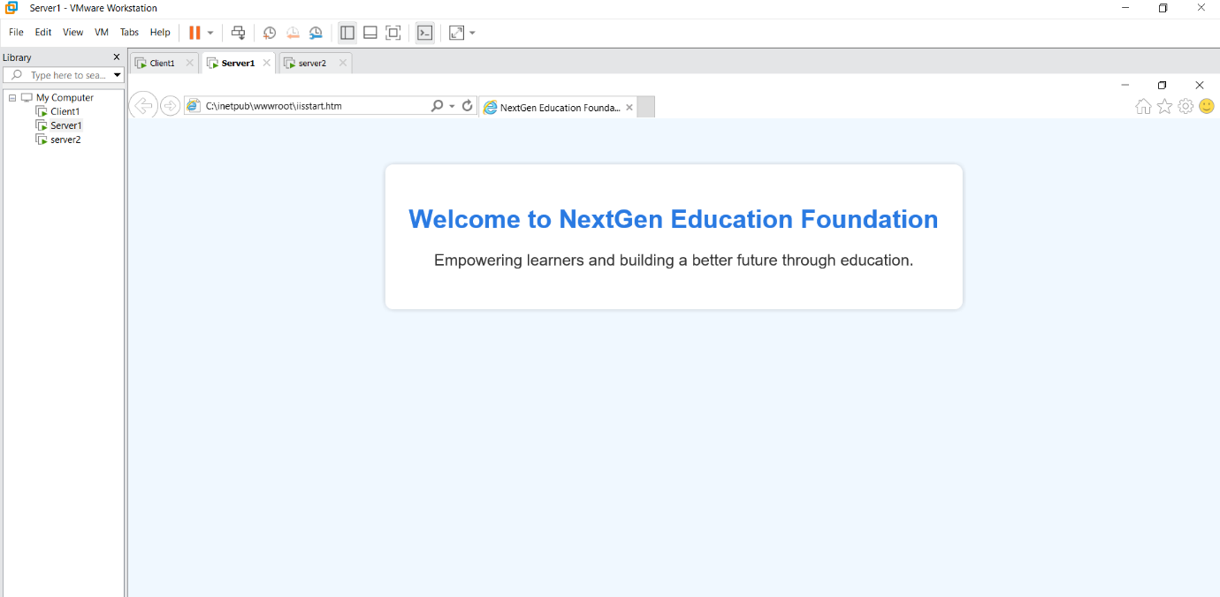
Also search : http://server1/ and http://192.168.10.1 show Website
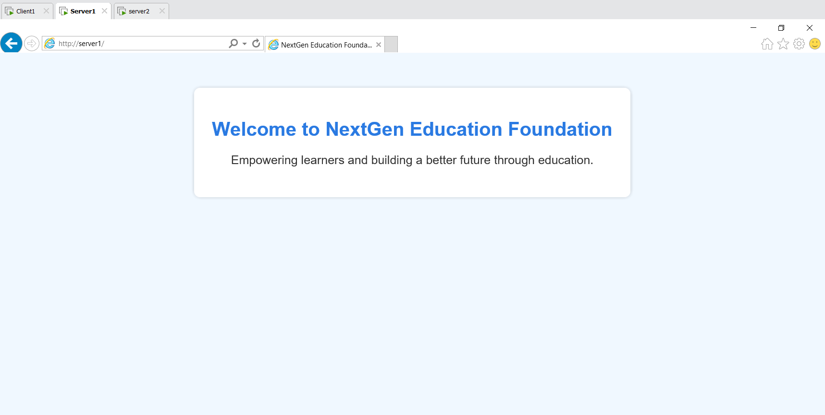
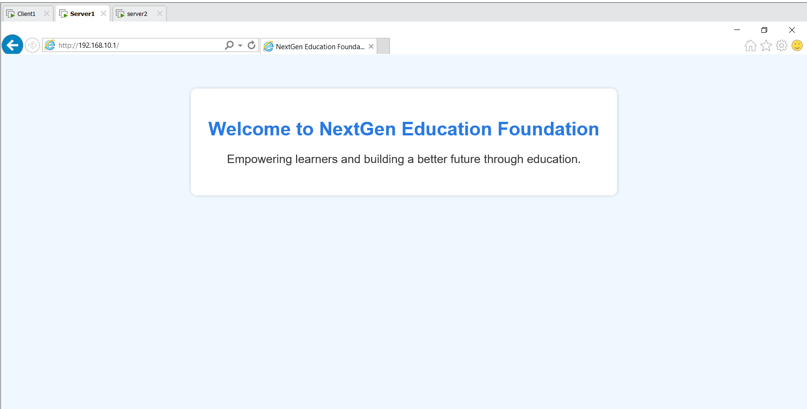
Server 1 :
Tool DNS Forward Lookup Zone Microsoft.com select CNAME give Alias name: training Fully Qualified Domain Name browse select server1.Microsoft.com ok
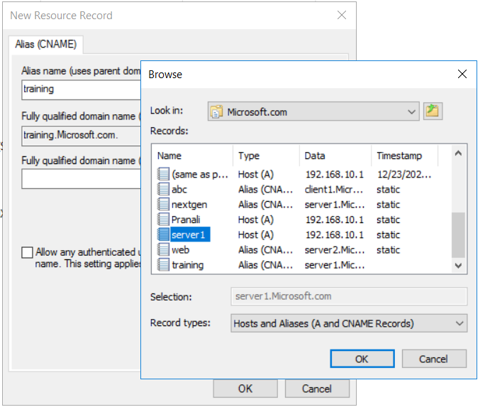
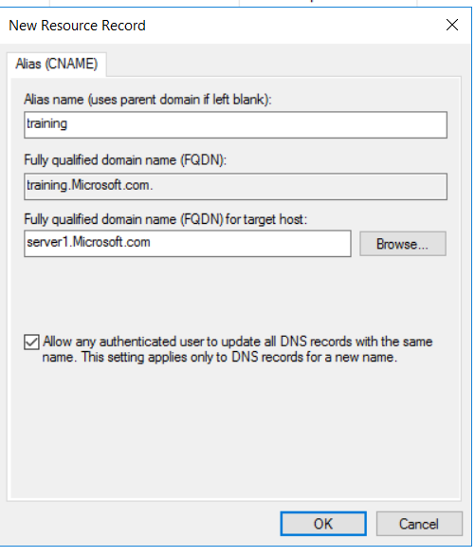
Internet Explore type http://training/ also open the website
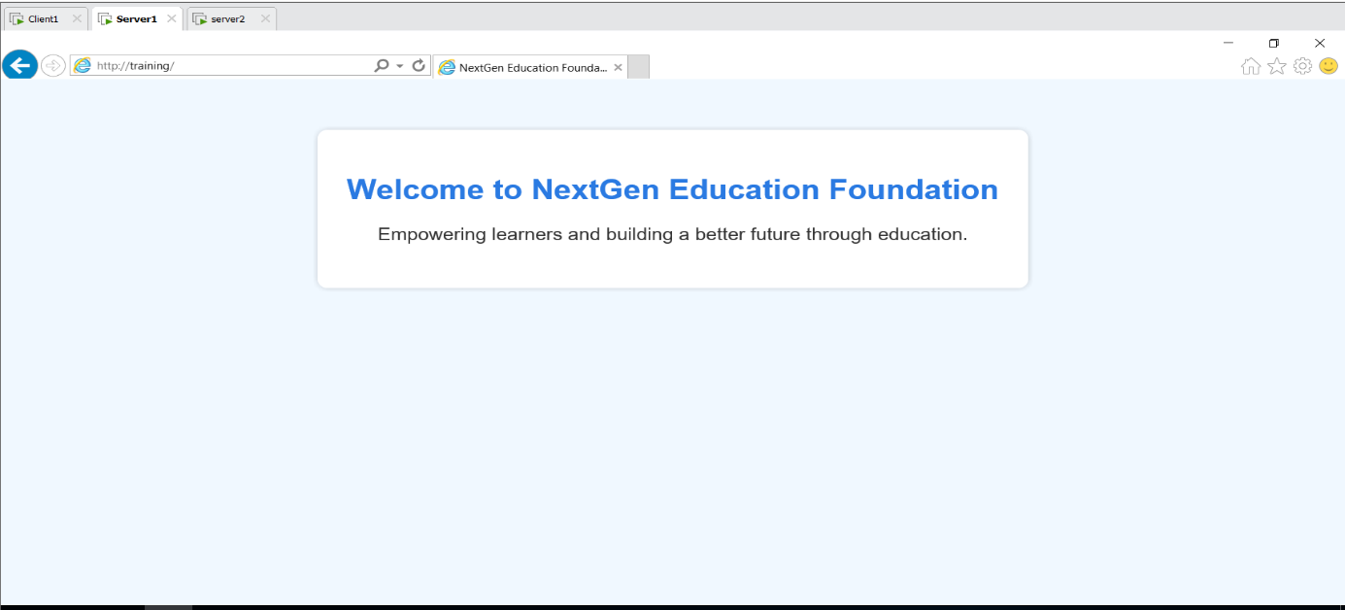
Server 2 :
Internet Explore type http://server 1/ also open the website
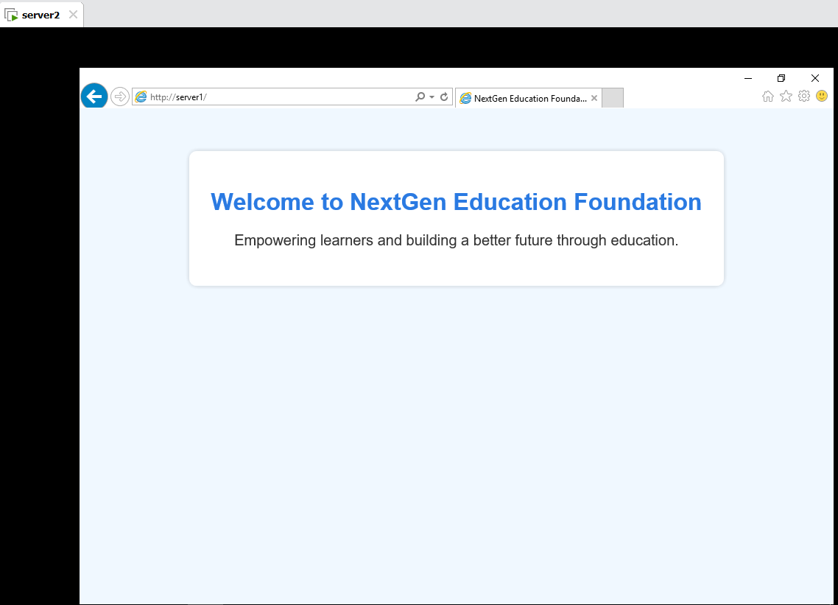
Client 1:
Internet Explore type http://server 1/ also open the website

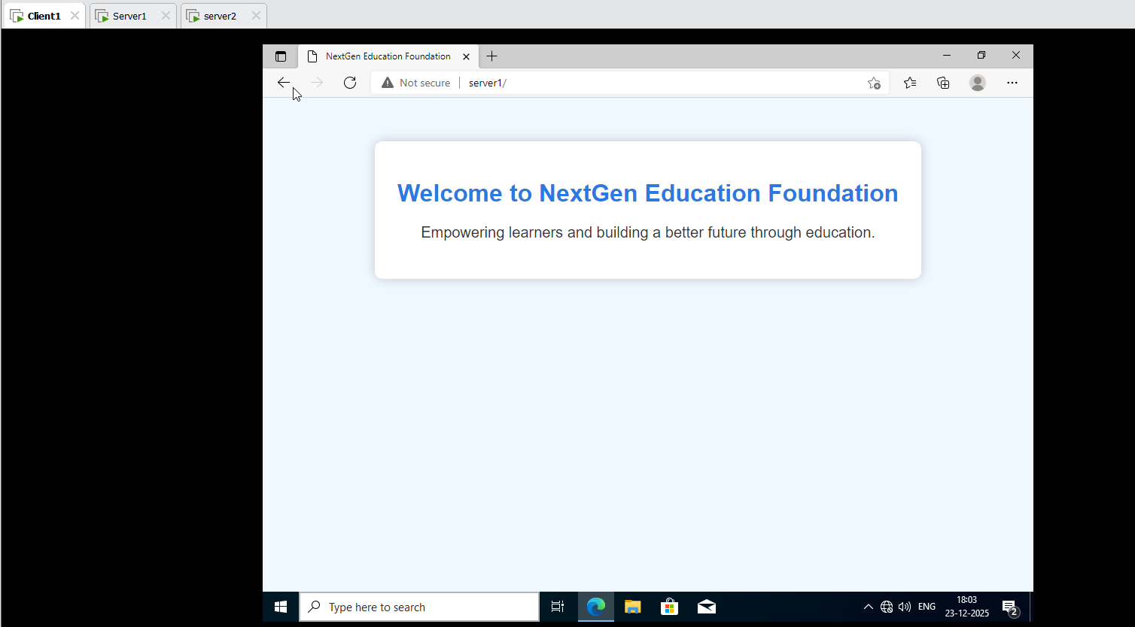

Shadow Copy:
Server 1:
This PC E drive Create Shadow Copy Folder create 4 File

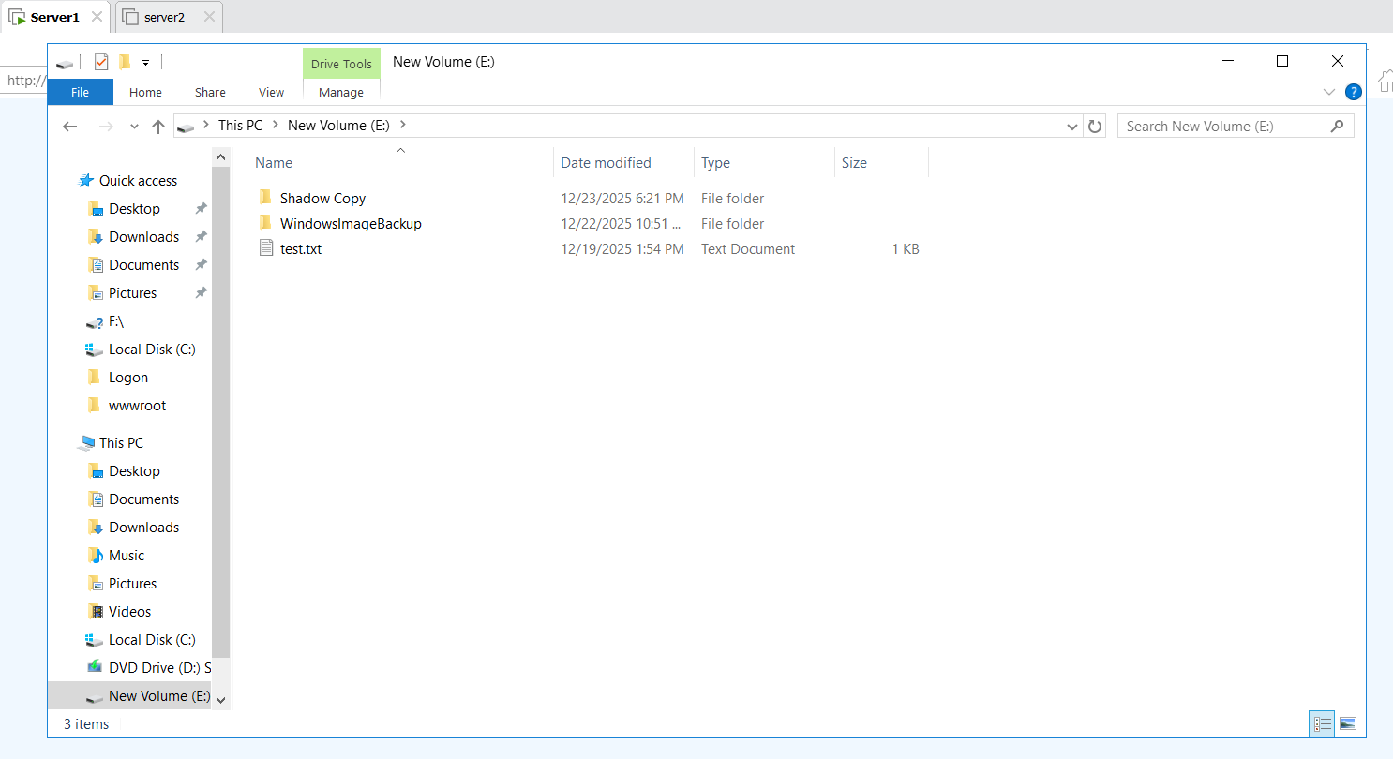
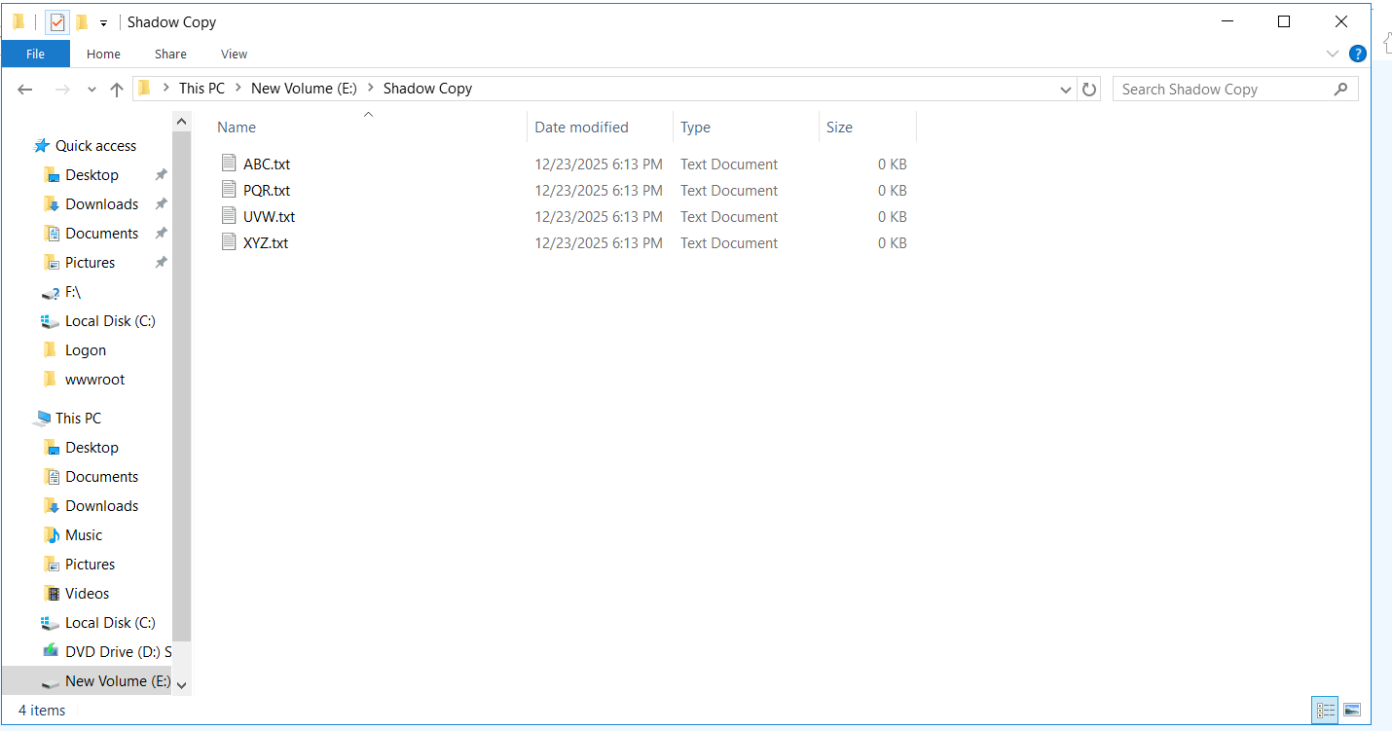
E drive Right Click on Properties Shadow Copies E drive has Disable click on E drive Enable ok

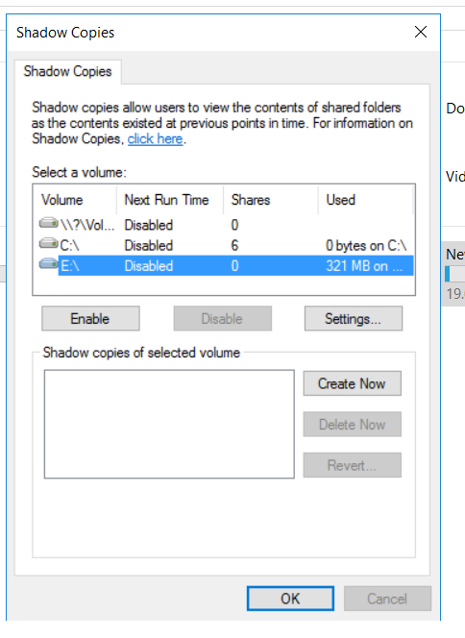
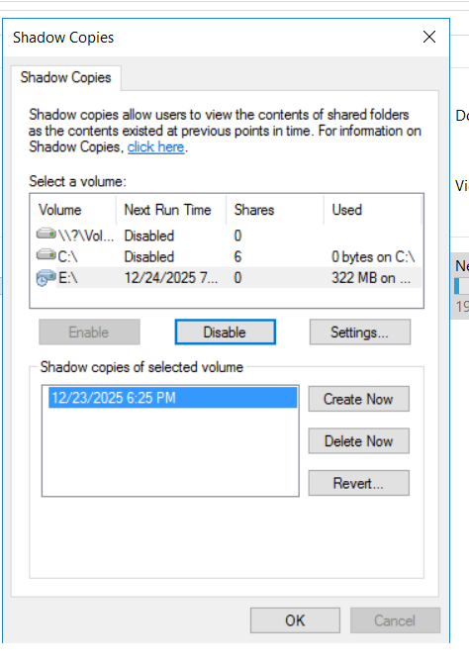
E drive Right Click on Properties Shadow Copies Previous Version Click on E drive Restore ok

